1. Login to SQL Server using admin account when you face the below error. Once you login to SQL server, ask the user to try using the time tracker after 10 mins. Check if SQL locks has been incured or not.

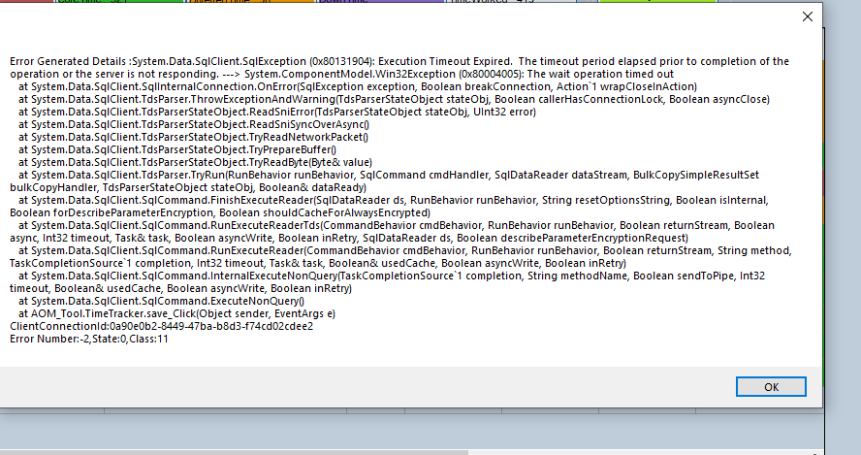

Following is the way for find the blocking transactions and killing it:

Check blocked by column and kill the session Id which is blocking it.

1. Make sure the volumes column has only integer values (numbers). Please refer the below error for the same.

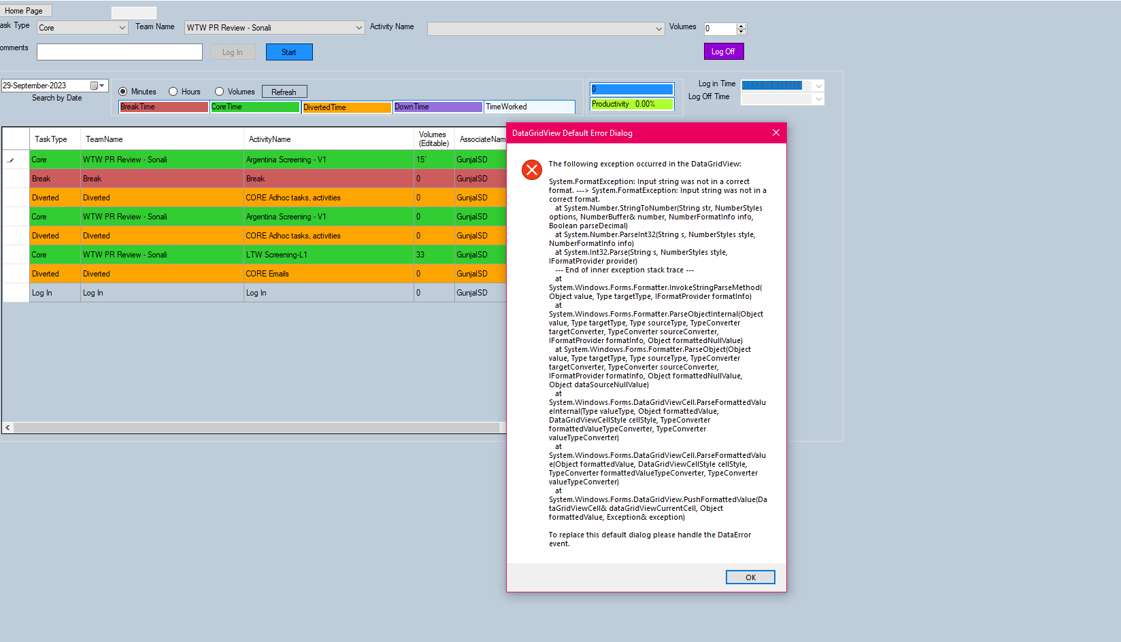

1. Update the data in Dot Net roster when the below error comes. After updating the roster, the error is still coming then you can let the associate know to ignore the error for the mean time. The productivity and utilization will be calculated afterwards.

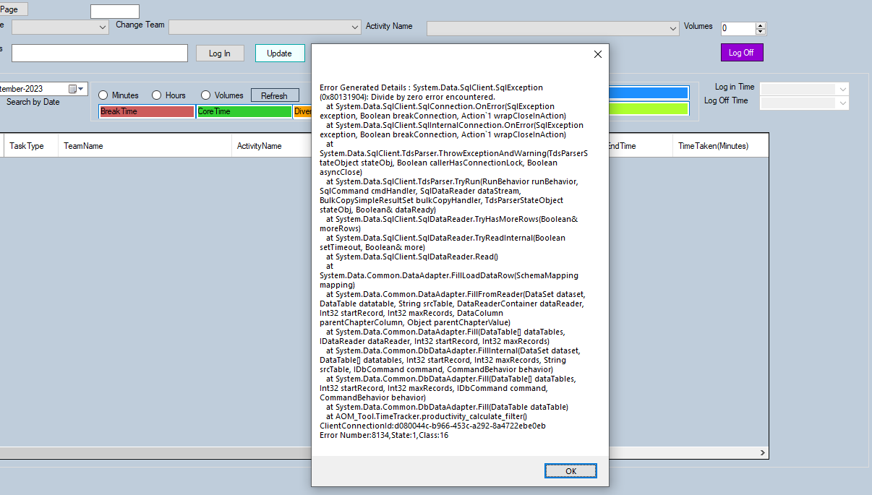

1. The below error comes due to low internet connectivity. Ask the user to download the tool, copy the file to the desktop and then open the tool file from desktop. If the error still comes, you can ask the user to try after some time (5 – 10 mins).

1. If the below error comes then ask the user, the download the latest copy of the file from the link. It might be possible that the user is using an older version of the file.

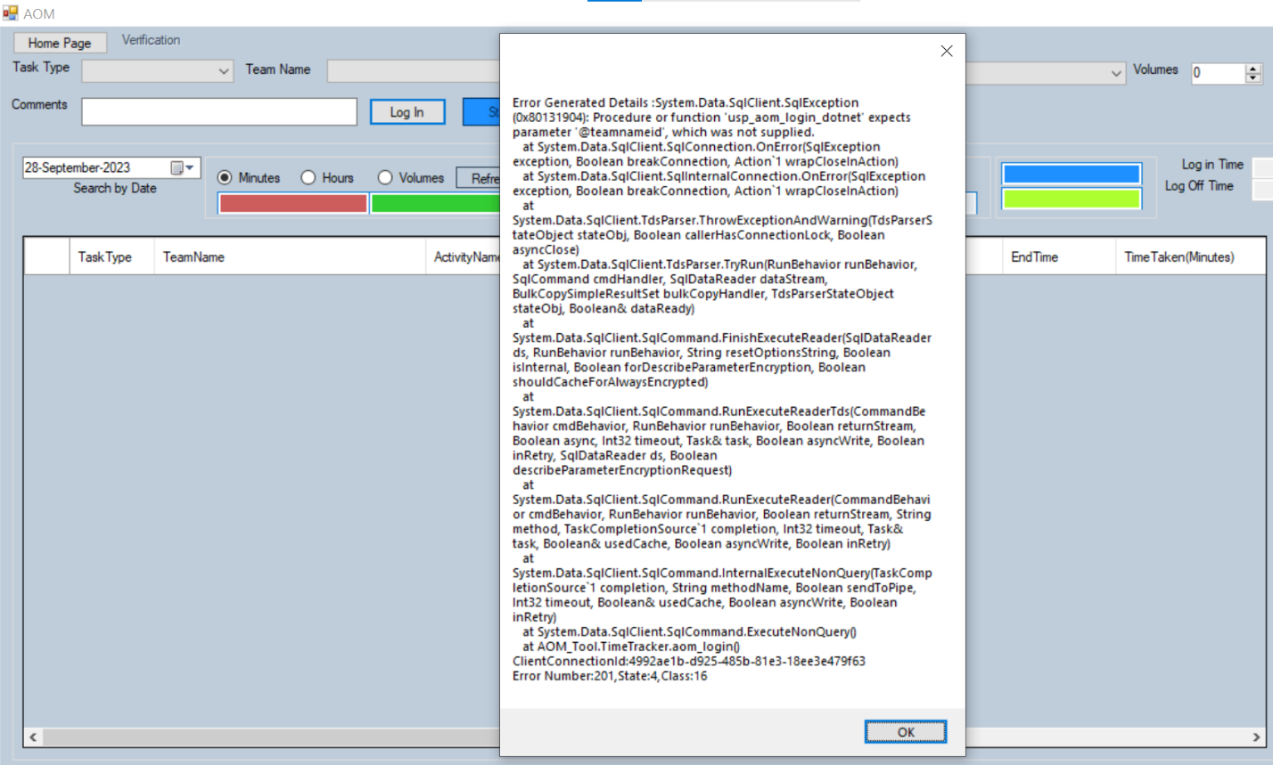

1. If the below error comes the delete the login and logout data of the user for that particular day and then ask to user to login again:

